# System GUI Design v2

System GUI Design 1

Login GUI 1

Main Menu GUI 2

Selling a ticket 2

Reviewing the Calendar 4

Managing the online website 5

Managing Sales Data 7

Managing Customer Data 8

Guide 9

Notes 9

## Login GUI

Include a space for error messages e.g. Invalid username

### Design overview:

#### Icons / buttons

* Makes ‘username’ field more identifiable
* ‘Caps lock on’ for visual aid
* ‘Show password’ option for visual aid
* ‘Forgot your password’ button should lead to an external site to handle the problem (clarify is this is necessary with customer)
* Error message shown whenever the wrong credentials is submitted

## Main Menu GUI

### Design overview:

Centralized navigation hub containing links to key functions of the system GUI, includes ‘exit’ and ‘view guide’ links

Common features grouped together e.g. Manage data

Optional: whenever the user’s mouse hovers over a button, it should appear different, example below

## Selling a ticket

After selecting an event the following GUI appears.

Ticket sale v3?? (GUI that appears after using selecting an event from the calendar while in the ticket sale option)

### Design overview:

An interface that displays event details in a table format with filtering options. Users should be able to select an event and enter ticket sale details.

‘Advanced filters’ for specific queries e.g. tickets purchased between the 11.03.25 -> 18.03.25 in ___ venue, opens separately

* Need clarification from customer if advanced filtering is necessary
* If so, this feature can be implemented in the following GUIs
  + Selling a ticket
  + Reviewing the calendar
  + Managing the online website
  + Managing sales data
  + Managing customer data

## Reviewing the Calendar

After selecting an event, the following GUI appears

Calendar v3??

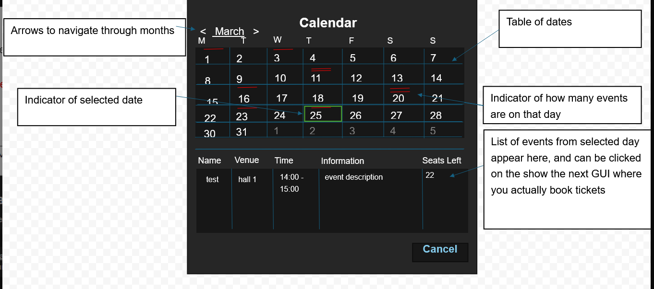

Design Overview:  
A interface that shows event data and allows the user to review and update the remaining tickets if needed. Events can be filtered and are displayed in a table format and the user is able to view seating information for any event.

## Managing the online website

*Website is a subset of the events on the calendar. Operations are responsible for adding events to the calendar, Box Office is responsible for adding events from the calendar to the website and selecting which seats can be booked online.*

If you select an event from the main GUI, the following GUI appears

If you were to click “add”, from the main GUI the following GUI appears. In this you can search from the calendar, click on an event then press add to add it to the online website.

(You can click an event from the main GUI and click “remove” to remove it from the online website)

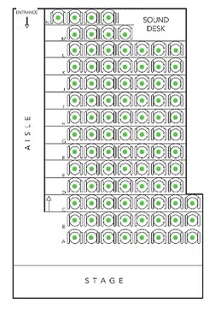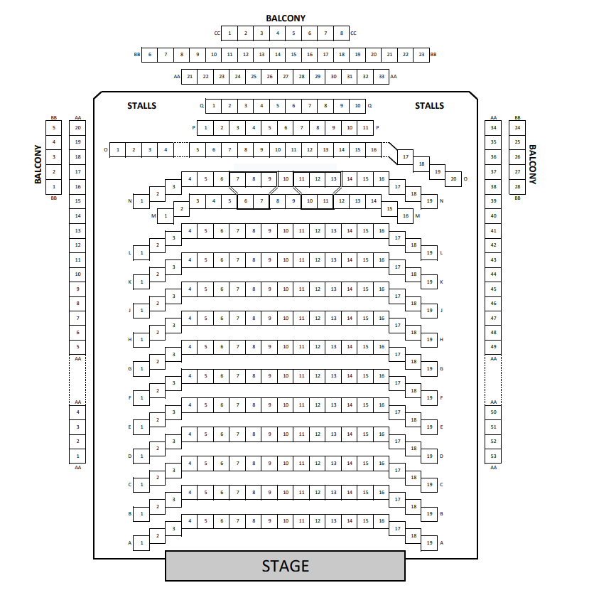

These are the seating plans for the Small-hall (first image) and Main- Hall (second image). We should aim to make this interactive so users can see the status (accessibility and availability) of the seats e.g. red = purchased, green = available. This is NOT a part of the System GUI but is useful to be aware of as the website should have this interactive seating plan.

Design Overview:  
An interface for handling website-related tasks such as adding events from the calendar to the online website and selecting which seats are available for online booking. It focuses on updating seat statuses (e.g. hold, accessible) for online sales.

## Managing Sales Data

Design Overview:  
An interface that displays sales data in a table format with filtering and export options. This view supports detailed analysis of ticket sales and revenue.

## Managing Customer Data

Design Overview:  
An interface for viewing and managing customer details. It lists customer information in a table format and allows filtering by various fields.

## Guide

*Optional: simple window printing the contents of a text file outlining how to use the program*

Design Overview:  
A simple guide window that provides instructions on how to use various parts of the system. It may be a scrollable text file or (as displayed by the diagram on top) a window with clickable sections.

## Notes

* “Selecting an event” means clicking it from the table of results.
* The refined version of the System GUI assumes that the table can be updated in real time (as you type into the search boxes), a search or refresh button can be added if necessary.
* Use the same color scheme, fonts, button styles, and icons across all GUIs.
* Provide clear visual cues because of user actions (e.g., hover states, error messages and confirmations).